[COMPUTING FUNDAMENTAL]

**SOLUTION:**

Musical instrument

Web camera

Touch screen

Scanner

Microphone

Game controller

Keyboard

Mouse

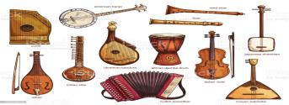

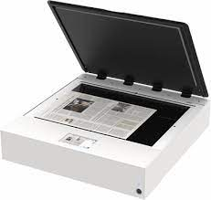

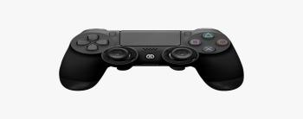

**Can you think of any?**

**OTHER INPUT DEVICES?**

**INPUT DEVICES** SEND DATA AND

CONTROL SIGNALS TO THE COMPUTER

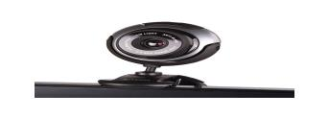

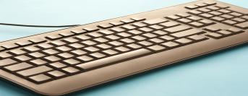

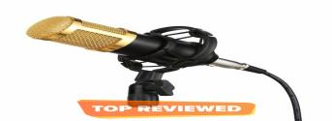

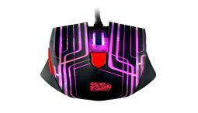

INPUT DEVICES

